Project Design Phase-II
Data Flow Diagram & User Stories

Date | 20 February 2025
Team ID | LTVIP2026TMIDS41763
Project Name | ShopEZ:One-Stop Shop for Online Purchases
Maximum Marks | 4 Marks

Data Flow Diagrams:
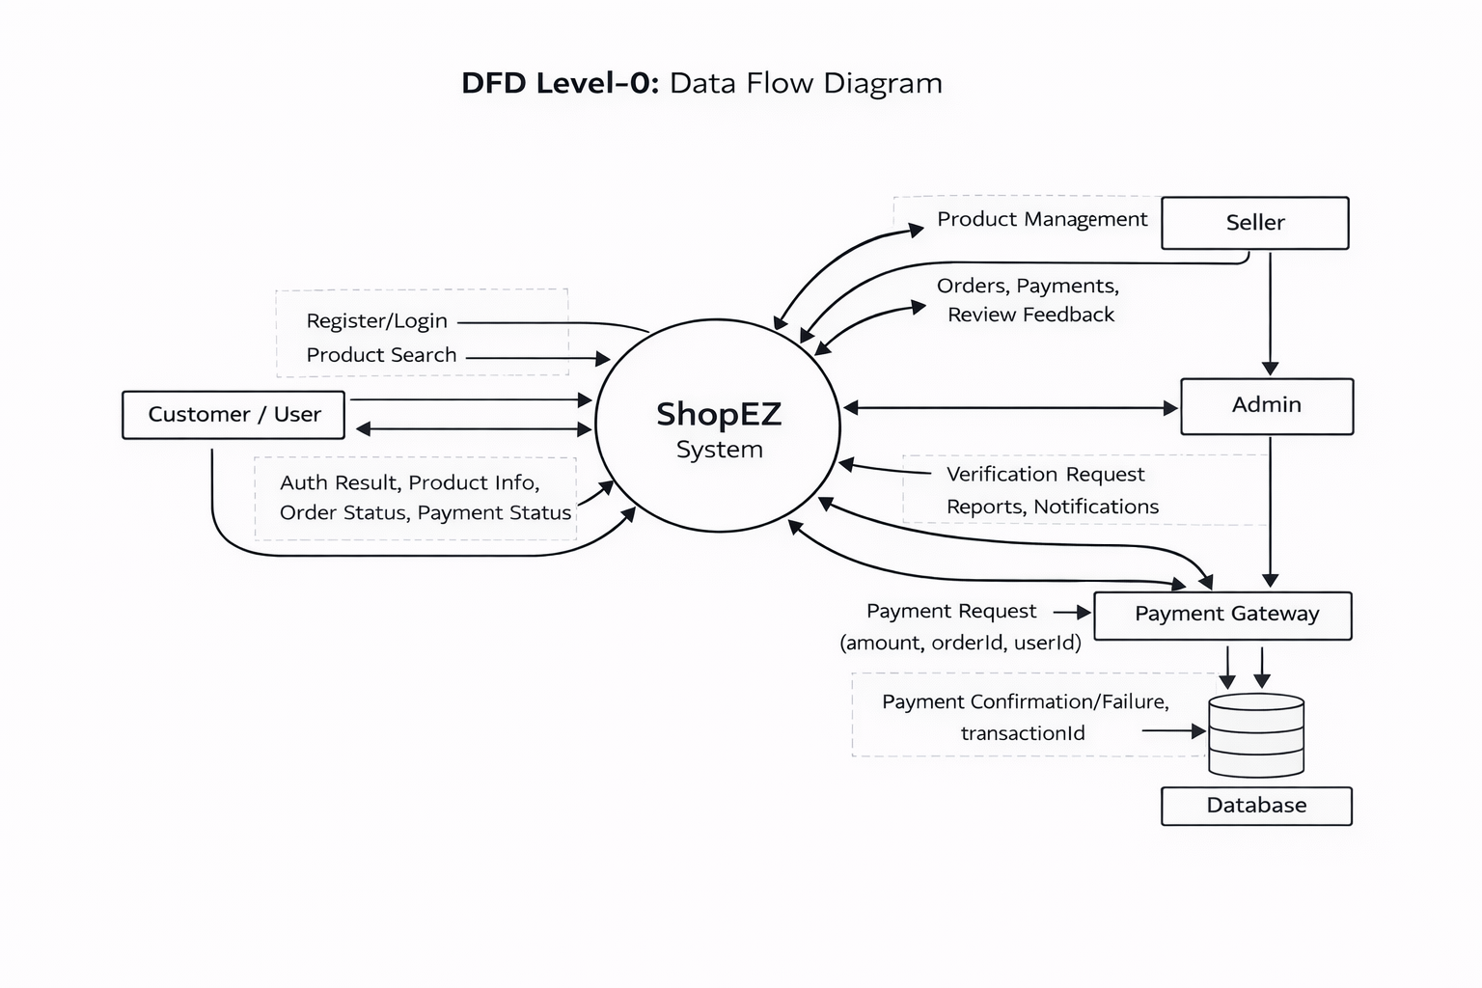
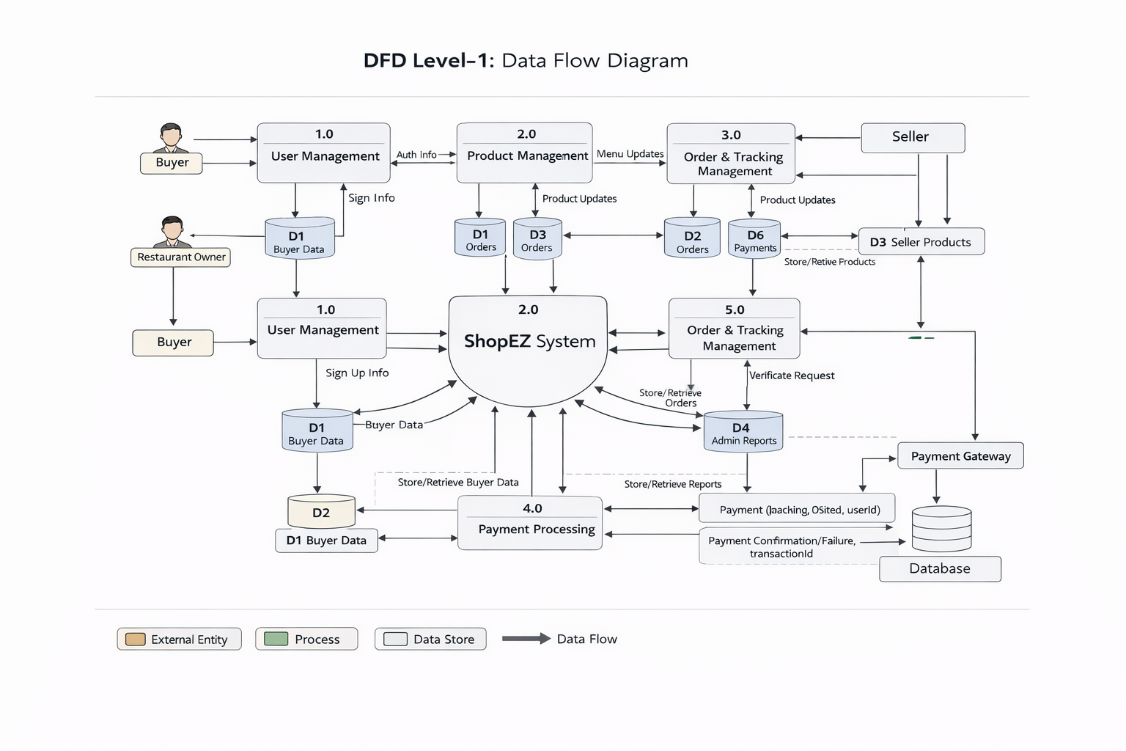
User Stories
Use the below template to list all the user stories for the product.
User Type | Functional Requirement (Epic) | User Story Number | User Story / Task | Acceptance Criteria | Priority | Release
Customer (Mobile user) | Registration | USN-1 | As a user, I can register using email, password and confirm password. | Account is created and user is redirected to dashboard/home. | High | Sprint-1
Customer (Mobile user) | Registration | USN-2 | As a user, I will receive confirmation email after registration. | User receives confirmation email and can verify account. | High | Sprint-1
Customer (Mobile user) | Registration | USN-3 | As a user, I can register through Google login. | User can sign up/login and access dashboard via Google. | Medium | Sprint-1
Customer (Mobile user) | Login | USN-4 | As a user, I can log into the application using email & password. | Valid credentials log user into dashboard. | High | Sprint-1
Customer (Mobile user) | Dashboard | USN-5 | As a user, I can view product listings on dashboard. | Dashboard displays product cards with images, price and details. | High | Sprint-1
Customer (Mobile user) | Product Search | USN-6 | As a user, I can search products by name or category. | Search returns relevant results with filter options. | High | Sprint-1
Customer (Mobile user) | Cart & Checkout | USN-7 | As a user, I can add/remove products to cart and update quantity. | Cart updates in real time and shows total price. | High | Sprint-1
Customer (Mobile user) | Orders | USN-8 | As a user, I can place an order from my cart. | Order is successfully created and order ID generated. | High | Sprint-1
Customer (Mobile user) | Payments | USN-9 | As a user, I can pay securely using online payment. | Payment is processed and order status updated. | High | Sprint-1
Customer (Mobile user) | Order Tracking | USN-10 | As a user, I can track my order status. | User can see order status (Placed/Shipped/Delivered). | Medium | Sprint-2

